**CVWO Final Assignment Writeup**

Having only some prior experience in HTML, CSS and JavaScript programming, using react with rails to build web application was a whole new concept for me. This means that I have to learn to build a react with rails website from scratch solely by myself without the help of any lecturer or teaching assistant that I am used to in school. Despite the challenges, I am glad I took on the challenge as I have accomplished increased competency in building the website frontend and backend components by doing self-learning.

Before embarking on the assignment, I didn’t even know how to set up a react with rails website. I am glad that I was able to find a YouTube video and follow the steps to set up the React with Rails framework so that I can program it using vscode. To learn react, I took on a Udemy course about web development and was able to follow through and did 2 other follows through projects before starting on the CVWO Assignments. After learning the fundamentals of React, I finally started frontend programming for the to-do-list application. I started using React to build different components that will be needed in my final website. I have learned that by building small components, it made the website very scalable and can even be reused in other projects or react native. Then, I started using CSS, Bootstrap and Semantic UI to create the website design are per the wireframe design in the Mid Assignment Submission. Learning to use CSS framework such as bootstrap and semantic UI makes designing the CSS faster and easier.

Thereafter, I moved into backend with rails. I have learned that rails are very efficient for a programming as it helps us generate the different html routes after indicating the resources under “routes.rb”. Database generation took me awhile to get used to, but I am glad that it was able to generate the table without the use of SQL statements. I was able to achieve the CRUD operations and later also included the tagging system after by adding a foreign key to the task database. As I initially used SQLite, it took me awhile to research and migrate it to postgres SQL but I am glad that I did it.

Finally, I did some testing to make sure that the website worked as what I wanted. Fixed some bugs and I was ready to deploy it to Heroku. Heroku has a comprehensive step by step guide to deploy the website and it didn’t take me long to finally deploy the website up to <http://eh-todolist.herokuapp.com/>.

Overview, I have accomplished and solved many minor problems along the way to build a to-do-list website that has a decent design and functionally. As I have learned, if I encountered programming problems along the way, there is a high chance someone else did too and solutions are available online given by the community. I am glad that I was able made a simple full stack website on my own and believe that I will be able to overcome any other challenges to come if I am selected for the CVWO module.

**User Manual:**

Website: <http://eh-todolist.herokuapp.com/>

**Add Filter Tag:**

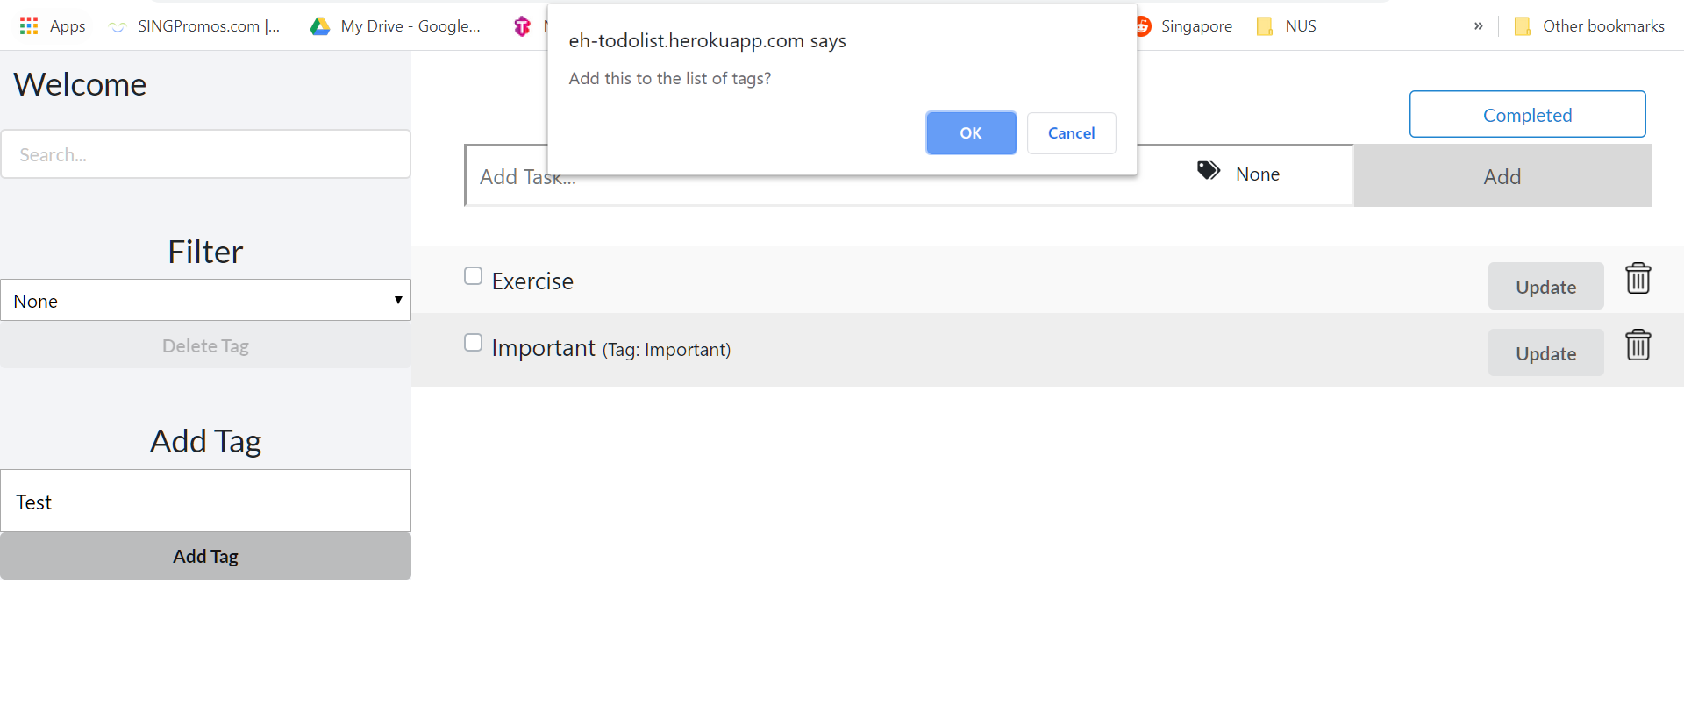

**Step 2:**

Press Add Tag

**Step 1:**

Enter Tag Description in the textbox

**Step 4 (End):**

Tag list will be updated here

**Step 3:**

Click “OK” when the alert box appears

**Filter Task:**

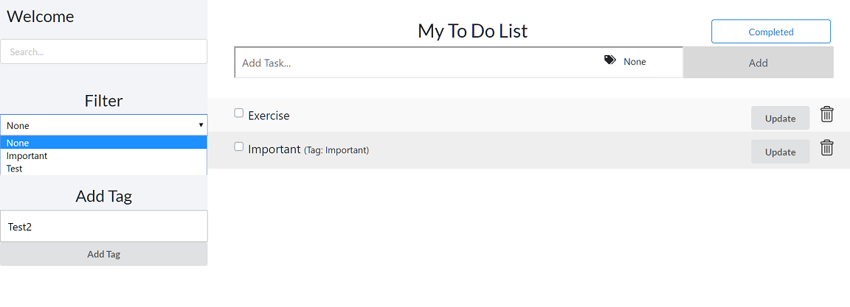

**Step 2 (End):**

Task will change automatically base on the chosen filter tag

**Step 1:**

Click on the filter dropdown to select filter

**Add Task:**

**Step 4 (End):**

Click on “Ok” button and task will be created

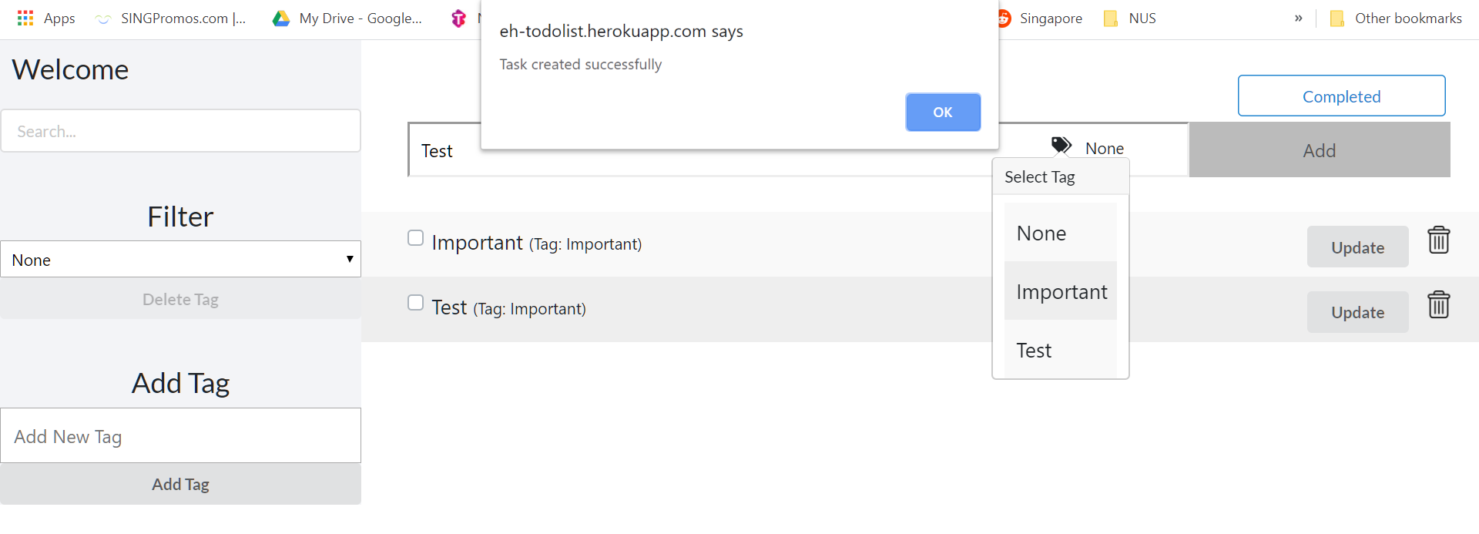

**Step 3:**

Click on “Add” button

**Step 2:**

Click on the “Tag” icon to add tag for the task

**Step 1:**

Enter Task Description

**Update Task:**

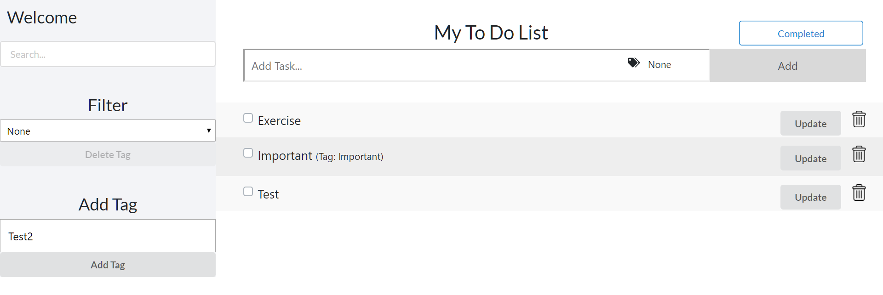

**Step 1:**

Click on the “Update” button to update a particular task

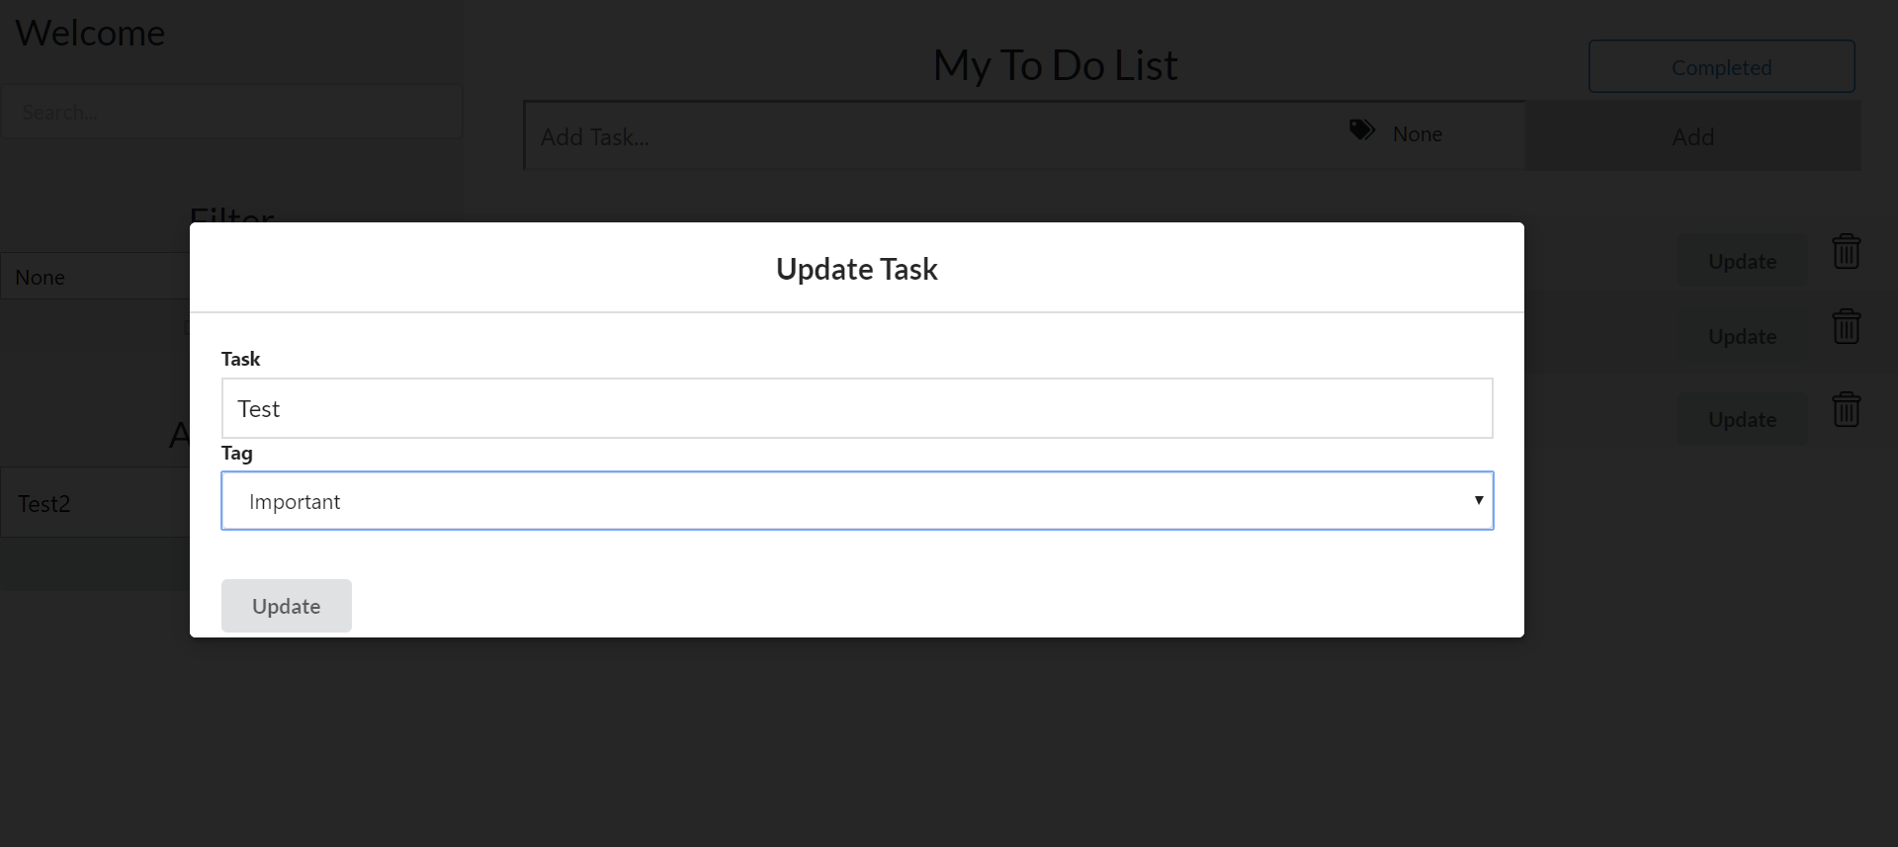

**Step 3 (End):**

Click on the “Update” button to update

**Step 2:**

A modal will appear, update the task description / tag as you like

**Delete Task / Delete Tag / Search Task:**

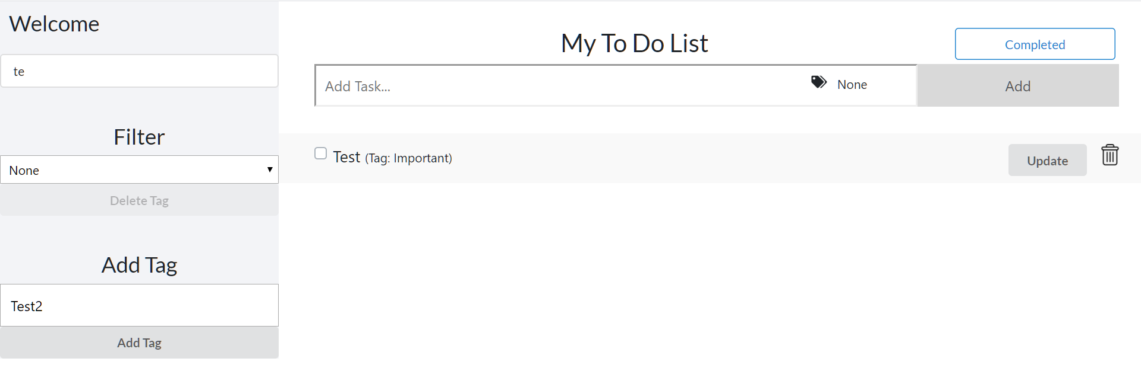

**Delete Tag:**

Select the tag from the dropdown, then click on “Delete Tag” to delete

**Search Task:**

Enter search in the textbox to search

**Delete Task:**

Click on the “bin” icon to delete a task

**Complete Task:**

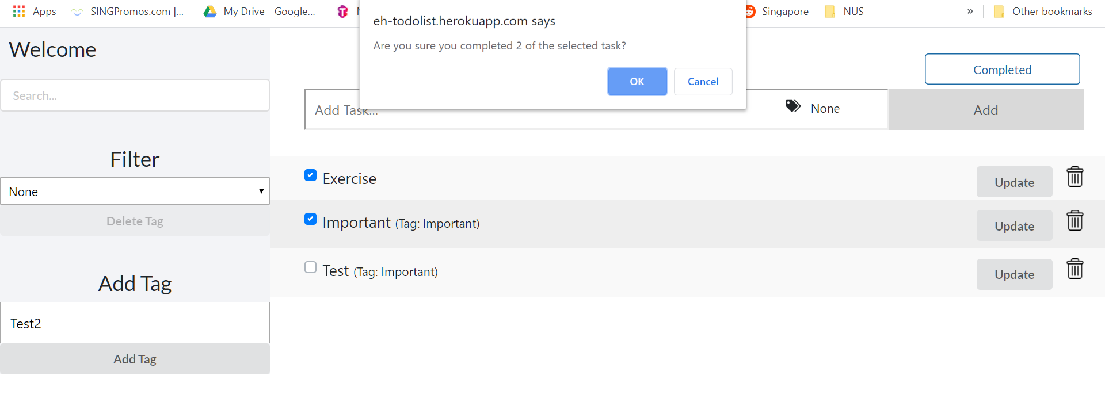

**Step 3 (End):**

Click on the “OK” button to delete the completed task

**Step 2:**

Click the “Completed” button

**Step 1:**

Check the task which has been completed